**Year 3 Calculation Methods**

Year 3 Maths builds on prior knowledge from year 2, securing understanding of numbers up to 1000.

We use a variety of calculation methods in Year 3, which are illustrated below:

**Addition**

**533 + 22**

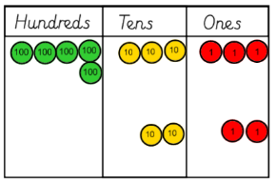 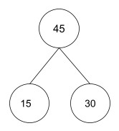

**Place Value Board & Counters Part-Part-Whole Model**

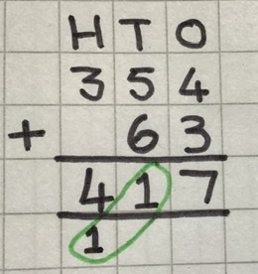

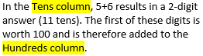

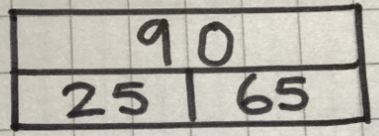

**Bar Model Column Method**

**Subtraction**

**713 -427 = 85 – 22 = 63**

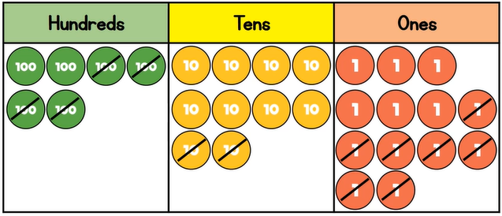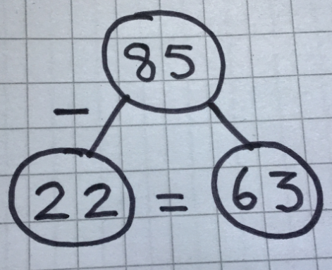

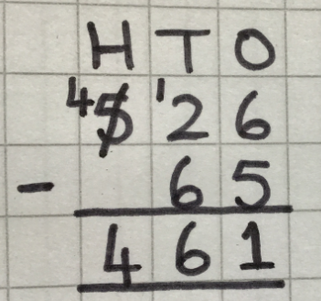

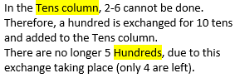

**Multiplication**

 **3 x 4 = 12 5 x 6 = 30**

**Arrays Repeated Addition**

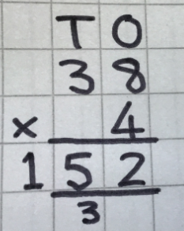 **23 x 4**

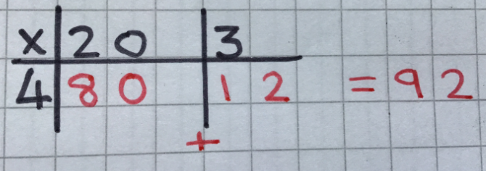

**Grid Method Column Method**

**Division**

**24 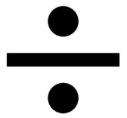 6**

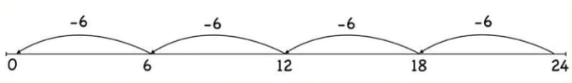 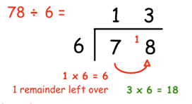

**Division by Repeated Subtraction Bus Stop Division**